Image | 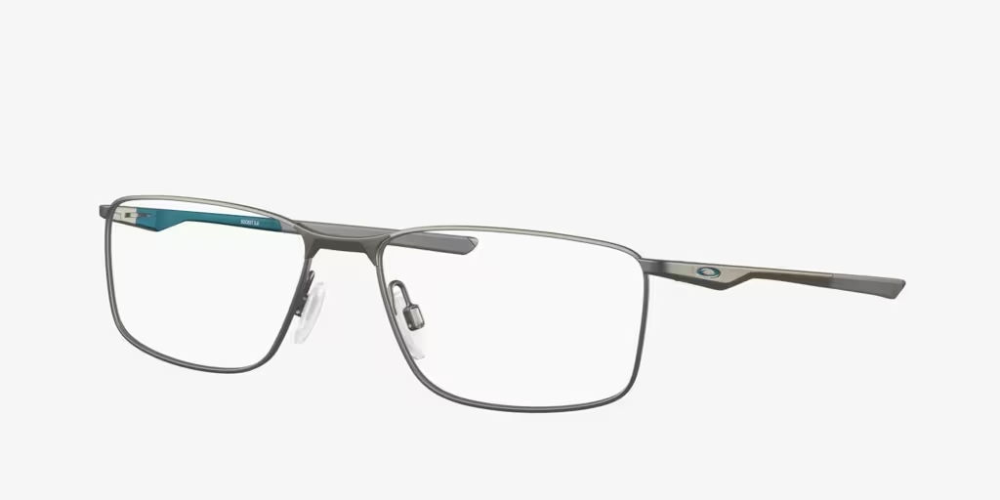
Brand | MICHEAL KORS
Model Name | OX3217 SOCKET
Price | RS 1200
PRODUCT DETAILS

